PG3302 opg 1
Task 1 Associations for class diagrams
Consider associations and choose whether they are aggregation or composition.
Aggregation implies a relationship where the child can exist independently of the parent.
Composition implies a relationship where child cannot exist without the parent.
source: https://www.visual-paradigm.com/guide/uml-unified-modeling-language/uml-aggregation-vs-composition/
- Datafile and folder the file is in. Datafile can exist without the file, but not the opposite.
This is aggregation
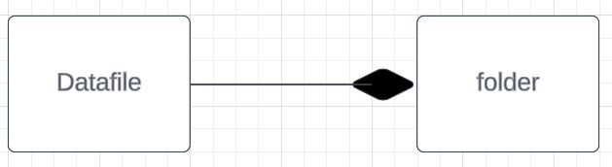

- Student and subject are aggregation.
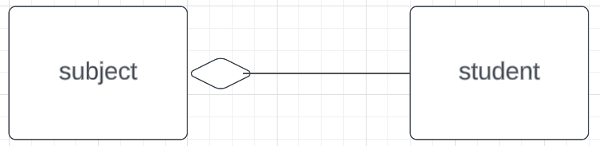
- Car and engine is aggregation
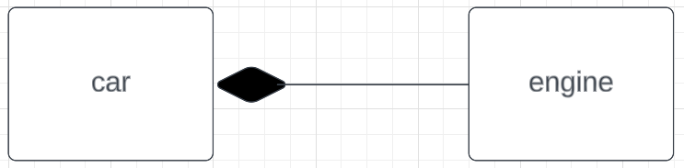
Task 2 Implemtentation Class diagram for an online store
- Customer/user/account
- Goods
- Shopping cart
- Order
- Payment
5-6 classes

